**Walchand College Of Engineering, Sangli**

(AnAutonomous Institute)



A Mini Project Report On

**Smart Agriculture**

Submitted by

Mr. Shubham Helaskar 2017BTEIT00073

Mr. Harshal Patil 2017BTEIT00024

Mr. Kushal Bafna 2017BTEIT00066

**Under the Guidance of Head Of Department**

**Prof. P.K.Kharat Dr. S. P. Sonavane**

Department of Information Technology

Third Year B. Tech.

*2019-2020*

**CERTIFICATE**

This is to certify that the project report entitled

**Smart Agriculture**

Submitted by

Mr. Shubham Helaskar 2017BTEIT00073

Mr. Harshal Patil 2017BTEIT00024

Mr. Kushal Bafna 2017BTEIT00066

Has undergone a Mini Project work and successfully completed in the academic year 2019-2020(SEM-I).

|  |
| --- |
|  |
|  |
|  |

Date: 15 Nov, 2019 Prof.P.K.Kharat

Place: Sangli (Project Guide)

**Acknowledgement**

We are rather infused by the kind guidance of Prof. P. K. Kharat who put in the cradle of our Engineering studies and evaluated us to this end and mean of our project. We could not have been able to complete the project without the valuable guidance of the Respected Panel. Class Teachers Mrs. B. S. Shetty gave her valuable guidance, experience and time to make the project a success. Without the guidance of all these respected members, we are sure to be orphans in the vast ocean of IOT . In the end, we would like to express a sincere thanks to all the people who helped us in the project completion directly or indirectly and feel lucky to have got their help.

**Contents:**

|  |  |  |
| --- | --- | --- |
| 1. | Abstract | 6 |
| 2. | Introduction | 7 |
| 3. | Problem Statement | 7 |
| 4. | Objectives  Hardware Specifications | 7 |
| 5. | Design and Circuit connection | 8 |
| 6. | Flow Diagram | 7 |
| 7. | Significance of project | 8 |
| 8. | Result | 9 |
| 9. | Analysis | 9 |
| 10. | Future enhancement | 10 |
| 11. | References | 10 |

**Abstract:**

Current global technology plays an important role in the field of agriculture. Automation is the technology with which a procedure or process is executed without human assistance. The main objective of this work is to determine how a person can use the automatic irrigation system of his own moderately economical facilities in a few hours to connect some electronic components and other materials. An automatic irrigation system based on sensor-based systems has been designed and implemented as one of the most widely used and advantageous automatic systems. This will help people in their daily activities, thus saving them time and hard work. This system uses sensor technology with the microcontroller, relay, DC motor and battery. Behave as an intelligent switching system that detects the soil moisture level and irrigates the plant if necessary. The ON / OFF motor will automatically be based on the dryness level of the soil. Sensor readings are transmitted to a computer to generate graphs for analysis. This type of irrigation system is easily controlled and controlled using a computer. In general, this system applies automatically for small and large gardens, nurseries, greenhouses and green roofs. This will also save time and energy, as well as minimize water loss. It will also help the farmer to benefit from the plantation without solving irrigation planning problems.

**Introduction:**

In India, agricultural land decreases day by day due to population growth. Almost 0.2 million people are added to the total population each year, while the estimated annual reduction of agricultural land is about 0.08 million hectares. That's why we need to increase food production every year, but our amount of land is not enough for this purpose. Smart technology is the best solution for this problem.

By using intelligent technology, it is possible to increase the efficiency of each irrigation site and save the economy. Now a days, roof gardening and greenhouse plants are the most popular for growing exotic fruits, flowers and vegetables, which are a very mild climate in India. In these cases, the system based on control is very efficient. In the automated plant irrigation systems estimate and measure the soil moisture and provide the desired amount of water to plant. Minimizes the excessive use of water and keeps the plants healthy. It is very essential to use resources appropriately. Therefore, a system is required to manage this activity automatically.

**1.2 Title of Proposed Project:**

**Smart Agriculture**

**1.3 Brief Introduction:**

Conditions of limited water resources have been impaired as a result of climate change led to the need of water for agriculture purposes increasingly competitive. This condition can cause an imbalance between supply and demand of water .Overcoming lack of water to improve productivity and efficiency of irrigation needs an effective and efficient technology implementation for irrigation management .Thus existence of an automatic irrigation system using Arduino uno is expected to be useful to facilitate irrigation in agriculture.

Automatic irrigation system is a prototype for a system of irrigation based on Arduino microcontroller integrated with proximity sensors (Soil moisture sensor), Relay, DC Motor.

**Problem Statement:**

Develop an IOT application project of automatic irrigation system using

Moisture sensor values.

**Objectives:**

* To increase yield production by proper supply of water to crops even in the absence of field owner.
* To prevent salinity of soil which can occur due to excessive irrigation.

**Hardware Specifications:**

1. Arduino UNO board

Arduino is a single card microcontroller designed to make the application more appreciable, that is interactive objects and the surrounding environment. The UNO board of Arduino is a microcontroller based on ATmega328. It has 14 digital input and output pins in which 6 can be used as outputs, a 16 MHz ceramic resonator, an ICSP header, a USB connection, 6 analog inputs, a power connector and a reset button. Contains all the necessary support controller required (Baraka etal.,

2013). It is presented by ATmega16U2 programmed as USB serial converter. It is a simple USB interface system.

2. Water Pump (DC, 12V)

For this study a water pump is required, which must be DC, 2V. The DC motor is the commonly used motor and has DC power distribution systems.

1. Jump Wire

A jump cable is used to connect the test plate, the prototype or the internal circuit with other non-joined instruments.

1. Arduino IDE Software

The Arduino Integrated Development Environment (IDE) is a cross-platform application for Windows, MacOS, Linux.

Written in the Java programming language. It is used to write in the java programming language.It is used to write and load programs on the Arduino board.The Arduino IDE provides a software library of the wiring project, which provides many input and output procedures.

1. Moisture Sensor

The humidity sensor is used to measure the water content (moisture) of the soil. This sensor reminds the user to irrigate their plants and also controls the moisture content of the soil.

Temperature sensor

Relay

**Design :-**

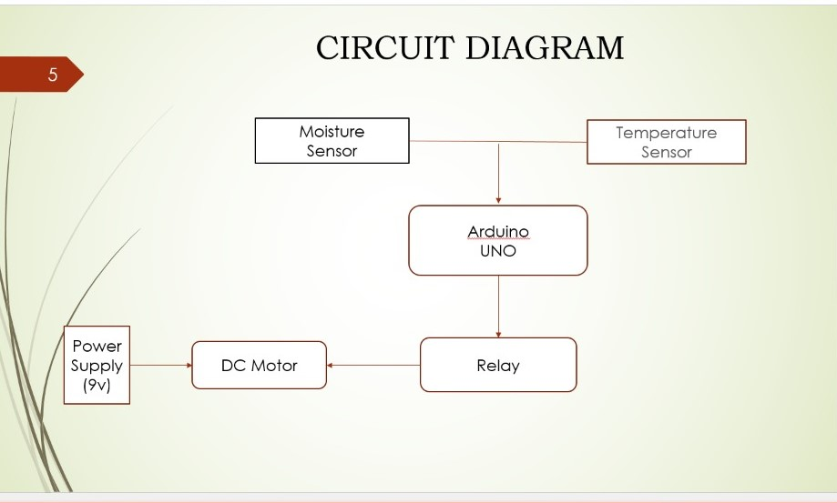

**Circuit Connections:**

Relay Arduino

GND ======> GND (digital)

IN1 **======>** 13

VCC=======> 5V

Temp Sensor Arduino

+========> 5V

- ========> GND (analog)

out=======> 8

Moisture sensor Arduino

VCC =======>5V

GND=======>GND(analog)

A0 =======> A0

**Result:**

Moisture and Temperature is sensed through sensors and data is send to arduino.

If field is dry then motor get starts and when field gets irrigated relay control power supply to motor and motor stops.

**Analysis:**

When moisture value is less than 30 motor starts else it stops.

**Future Enhancements:**

We Extends this project for suitable crop recommendation using machine learning by taking data from website where data in website is fetched from arduino.

**References:**

* SMAJSTRLA, A.G.; KOO, R.C.."Applied engineering in agriculture.

* CLEMENS, AJ. Feedback Control for Surface Irrigation Management in: Visions of the Future. ASAE Publication 04-90. American Soceity of Agricultural Engineers, St. Joseph, Michigan, pp.255-260.

# Smart Irrigation || Automated irrigation process using Arduino Moisture sensor and water pump

Link:-https://www.youtube.com/channel/UCirCYAchPacnEruPOPmCTVw

* Introduction-to-Arduino-uno.

h<ttps://www.theengineeringprojects.com/2018/06/introduction-to-arduino-u>no.html

httpcreate.arduino.cc/projecthub/electronicprojects/smart-irrigation-system-using- arduino-uno-afcb31